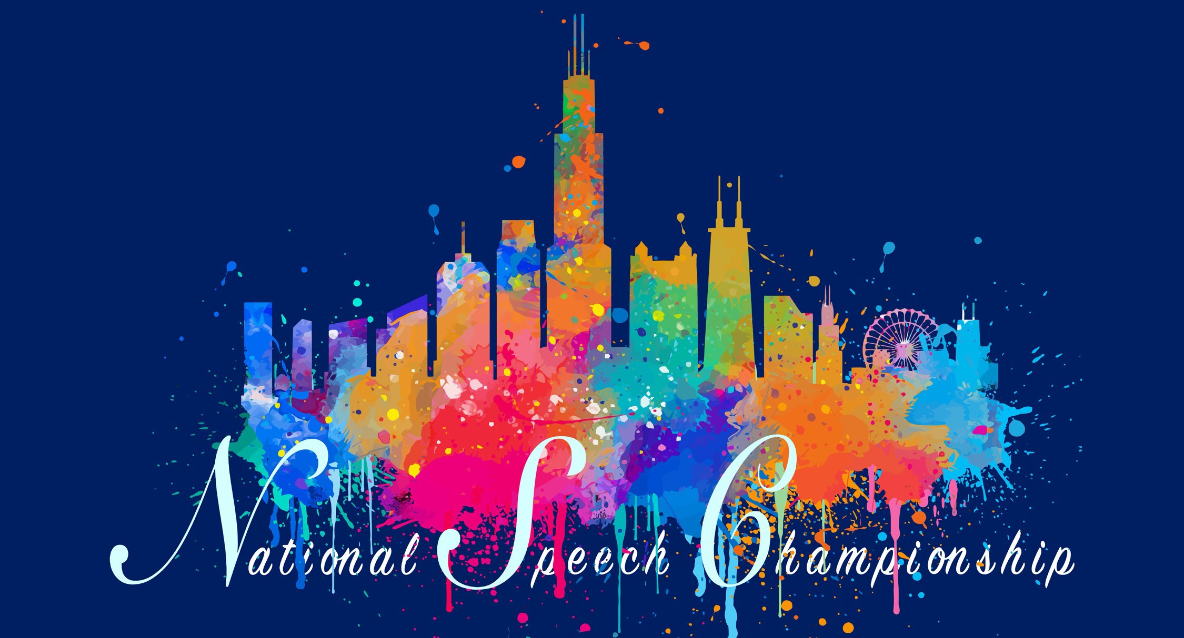

With immense appreciation, you are invited to join us in Chicago, Illinois for the National Speech Championship on March 23rd and 24th, 2024.

This year’s tournament will take place in-person at The University of Illinois Chicago
This tournament will provide an opportunity for teams of all resource levels to once again compete for a national team championship. The competition will be incredible and opportunities for both individual and team placement will abound. Congratulations to Bradley University for winning the 2023 National Speech Championship.
Thank you to the hundreds of individuals who have supported The National Speech Championship over the years by competing, coaching, running the tournament, and judging. I also want to extend a thank you to all of you who will be joining us this year.

Entry Fees
There will be no charge for any entries covered by judges. Teams are asked to provide enough judges to cover their entry. Each judge will cover six entries. Hired judges will be available at a rate of $40 per uncovered entry. If this fee prevents any team from
attending the tournament, that team may contact the tournament director, Ryan Lauth, at info@nationalspeechchampionship.com, for a fee waiver. The tournament is happy to provide this fee waiver as a means to support forensics participation around the nation.

Entries will be due via Speechwire.com by March 12th --- If you can enter earlier, please do so!

Entry Limits
Each team will be allowed a maximum of two entries per event. A single student may enter Duo twice if each Duo has a separate partner. A single student can be entered in each event, other than Duo, only once. There are no flight restrictions for individual students, however judges will be asked not to wait for competitors past the beginning of the following round in order to keep the tournament on schedule. There will be no qualification process necessary for entry.
The exception to the maximum limits are Interviewing and Group Improv. Each team may enter a maximum of five entries in Interviewing and one entry for Group Improv. Points will not be awarded for Interviewing or Group Improv.

Novice
Students in their first year of collegiate competition are allowed to be entered as novice on Speechwire. They will compete in the open division but will be eligible for novice exhibition finals only if they do not advance in that event to open elimination rounds. There will be no ranking of the novice exhibition final rounds. Instead, a moderator will run the round and offer only feedback on ballots. Novice final round competitors will be recognized during the awards ceremony. There will be no points awarded for novice final rounds.

Scoring
No points will be earned in preliminary round competition. There will be two judges in each preliminary round. Elimination round placement will be determined based on each entry’s three best ranks. Only the highest placing entry from each team in each event will score points. Points will be determined by adding all of the elimination round placements along the following scale:

Quarter finals = 1point Semi finals = 2 points
6th place = 2 points 5th place = 4 points 4th place = 6 points 3rd place = 8 points 2nd place = 10 points 1st place = 12 points
A student winning an event will therefore earn 15 team points. All teams will earn 20 points for attending the tournament.

Awards
Medals will be awarded to all elimination round competitors, including those in Interviewing and Group Improv. Traveling team trophies will be awarded to the top ten teams based upon points from elimination rounds. Each of these trophies will include the engraved names of the participating coaches and students from the team earning that trophy. The traveling team trophies will need to be returned to the tournament the following year. The top fifteen teams will also receive a team trophy to keep.
A traveling cumulative award will also be given to the team earning the most points in tournament history with points being reset to zero after winning.
Recognition will also be given to the top three non-scholarship programs, the top three two-year institutions, the top three programs directed by undergraduate students, and the top three programs directed by graduate students.

Tournament Weekend Schedule

Friday, March 22nd 2024:
5:00pm-6:00pm Early Registration
6:00pm-7:00pm Voluntary Coaches Meeting

Saturday, March 23rd 2024:
Preliminary Rounds
6:30am-7:00am Late Registration
7:30am-Extemp Draw 8:00am-Round 1A
(Extemp, Duo, CA, Interviewing, Prose, Persuasion, Group Improv)
9:30am- Round 1B
(Impromptu, Poetry, Drama, ADS, Info, Program)
10:45am-Extemp Draw 11:15am-Round 2A
(Extemp, Duo, CA, Interviewing, Prose, Persuasion, Group Improv)
12:15- Lunch Break 1:00pm- Round 2B
(Impromptu, Poetry, Drama, ADS, Info, Program)

Saturday, March 23rd 2024:
Elimination Rounds
2:30pm- A Quarter-Finals postings 2:45pm- Extemp Draw
3:00pm- A Quarter-Finals
(Duo, CA, Interviewing, Prose, Persuasion) 3:00pm- Group Improv Semi-Finals 3:15pm- Extemp Quarter-Finals
4:30pm- B Quarter Finals Postings 4:45pm- B Quarter Finals
(Impromptu, Poetry, Drama, ADS, Info, Program)
6:15pm - Group Improv Finals 6:45pm- A Semi-Finals Postings

Sunday, March 24th 2024:
7:45am- Extemp Draw 8:00am- A Semi-Finals
(Duo, CA, Interviewing, Prose, Persuasion) 8:15am- Extemp Semi-Finals
9:15am- B Semi-Finals Postings 9:30am- B Semi-Finals
(Impromptu, Poetry, Drama, ADS, Info, Program)
10:45am- A Finals Postings 11:00am- Extemp Draw 11:15am-A Finals
(Duo, CA, Interviewing, Prose, Persuasion) 11:30am- Extemp Finals
12:15pm- Lunch Break
12:45pm- B Finals Postings 1:00pm- B Finals
(Impromptu, Poetry, Drama, ADS, Info, Program)
3:00pm - Awards

Event Descriptions

Extemporaneous Speaking

An extemporaneously delivered speech that answers a question based in current events. Students will have thirty minutes to prepare. Time signals will be provided during the speech. The maximum time limit for the speech is seven minutes.
Duo Performance
A performance by two students. The students should primarily maintain off stage focus. Original commentary by the students should be provided that includes the title and author of any text used in the performance. The maximum time limit will be ten minutes.
Communication Analysis
A speech that incorporates communication focused research to explore a communicative act. The maximum time limit will be ten minutes.
Prose Performance
A performance of prose. Original commentary by the student should be provided that includes the title and author of any text used in the performance. The maximum time limit will be ten minutes.
Persuasive Speaking
A speech designed to persuade the audience to change their attitude, beliefs, values, or behavior. The maximum time limit will be ten minutes.
Informative Speaking
A speech designed to inform the audience. The maximum time limit will be ten minutes.
Program Performance
A performance that incorporates multiple genres of text. Original commentary by the student should be provided that includes an argumentative justification for the collection of texts as well as the title and author of any text used in the performance. The maximum time limit will be ten minutes.
Impromptu Speaking
A speech delivered after minimal preparation time. The student will have seven minutes total to prepare and speak after being given a prompt. Time signals will be provided. The maximum time limit will be seven
minutes.
Poetry Performance
A performance of poetry. Original commentary by the student should be provided that includes the title and author of any text used in the performance. The maximum time limit will be ten minutes.
Dramatic Performance
A performance of material that was created specifically for live or broadcast presentation. Original commentary by the student should be provided that includes the title and author of any text used in the performance. The maximum time limit will be ten minutes.
After Dinner Speaking
A speech designed to use humor to make a point. The maximum time limit will be ten minutes.

Interviewing
Responses to typical questions posed by a judge/interviewer. The interview will be for placement in a specific organization. The maximum time limit of the interview will
vary by round.
Preliminary rounds will be five to ten minutes and elimination rounds will range from five to twenty minutes.

Group Improv
A performance delivered after minimal preparation time. Groups will consist of 2 to 5 students. Groups will have seven minutes total to prepare and perform after being given a prompt. Time signals will be provided. The maximum time limit will be seven minutes. Prompts will vary by round.

Interviewing and Group Improv will not count toward sweepstakes points.

Judge Policies
The tournament will provide a full list of judges to all coaches during the week prior to the tournament and via Speechwire (the Files to download section) on Friday evening - a tradition since the first National Speech Championship. If your students have any conflicts with judges for non-competitive reasons, please inform the tournament so we can block the judge from
judging the student. This is an easy thing for us to do with Speechwire. Examples of when this could happen might include: the student is a family member/close friend of the judge, a
student was harassed/assaulted by the judge, a student was a teammate of the judge, a student was coached by the judge. We absolutely respect the privacy of these decisions. Students can inform the tournament through their coach or inform the tournament director directly at info@nationalspeechchampionship.com. The tournament director will not ask for details and does not expect any. We trust in the decision of the student. We hope that if a judge has participated in improper behavior that the tournament director be notified so that, if necessary, the judge can be removed from the judging pool before interacting with students, but it is not required if the student does not feel comfortable doing so.
Judge Limitations
We ask that judges not judge students or teams they coached, competed for, or received payment from (including working at summer camps but not including judging at tournaments) in the last four years. These blocks should be noted in the judge notes section when entering judges on Speechwire.

